**Game Project Report**

**Snake Game**

**Submitted by**

**001009958**

**CT30A2910 Introduction to Web Programming**

**LUT University, Lappeenranta**

**October 23, 2022**

**Introduction**

The goal of this game project is to create simple game using HTML, CSS and JavaScript. For my project, I have decided to create snake game where the objective of the game is to score as many point by eating apple. The user has to score points without getting killed by bumping itself in wall or in its own body. For our project, I have implemented programming taught in CT30A2910.

**Game Description**

Welcome to simple **Snake Game**. In this game, the user has to score points by eating food that is apple with each apple user will get one point and score will be added as user eats more and more. The game is simple and easy to use the controls of the game is key up to go up, key down to go down, key left to go left and key right to go right. The main aim of user would be to play game without getting killed by bumping itself in wall or in its own body. There is music in the game and also the sound effect when the snake is bumped on the wall or in its own body.

**Characters**

1. The snake



1. Food



1. Wall

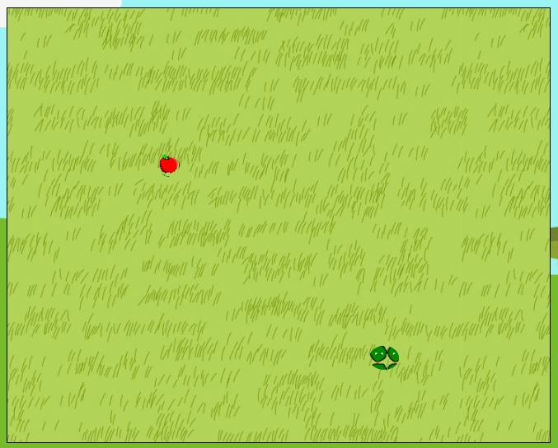

**User Manual**

The player controls the game play using particular keys on the keyboard. Keys available for the player are listed below.

**Direction Keys:**

* Key Up: Move the snake upwards.
* Key Down: Move the snake downwards.
* Key left: Move the snake to left side.
* Key right: Move the snake to right side.

**Other:**

* Press any key to continue game after you are dead in game.
* Player can reset the high score by pressing reset button on lower right.

**Conclusion**

I am thankful to the LUT University, my professor Erno Vanhala and assistant professor Vili Huusko for giving me opportunity to take course of such importance and continuous guidance whenever I find difficult on study.

I would be grateful to receive point in between 18-25, though the game is not the best but simple. As this is my first time creating a game and effort that I put in this game is really valuable. I have met almost all the requirement as the guidance given in moodle.

It’s the simple game but I hope people will like and provide me feedback necessary for further improvement.

**Thanking you (Kiitos),**

**001009958**